I’ve always loved the idea of Airbnb exploring new places and booking unique stays. But every time I opened the app, especially when I just wanted to book something quickly, I found myself… lost.

The home screen felt like a wall of cards, text, and categories screaming for attention. And by the time I figured out what I wanted, I already felt drained. That’s when I thought: What if I could redesign Airbnb for people who just want to book quickly without all the clutter?
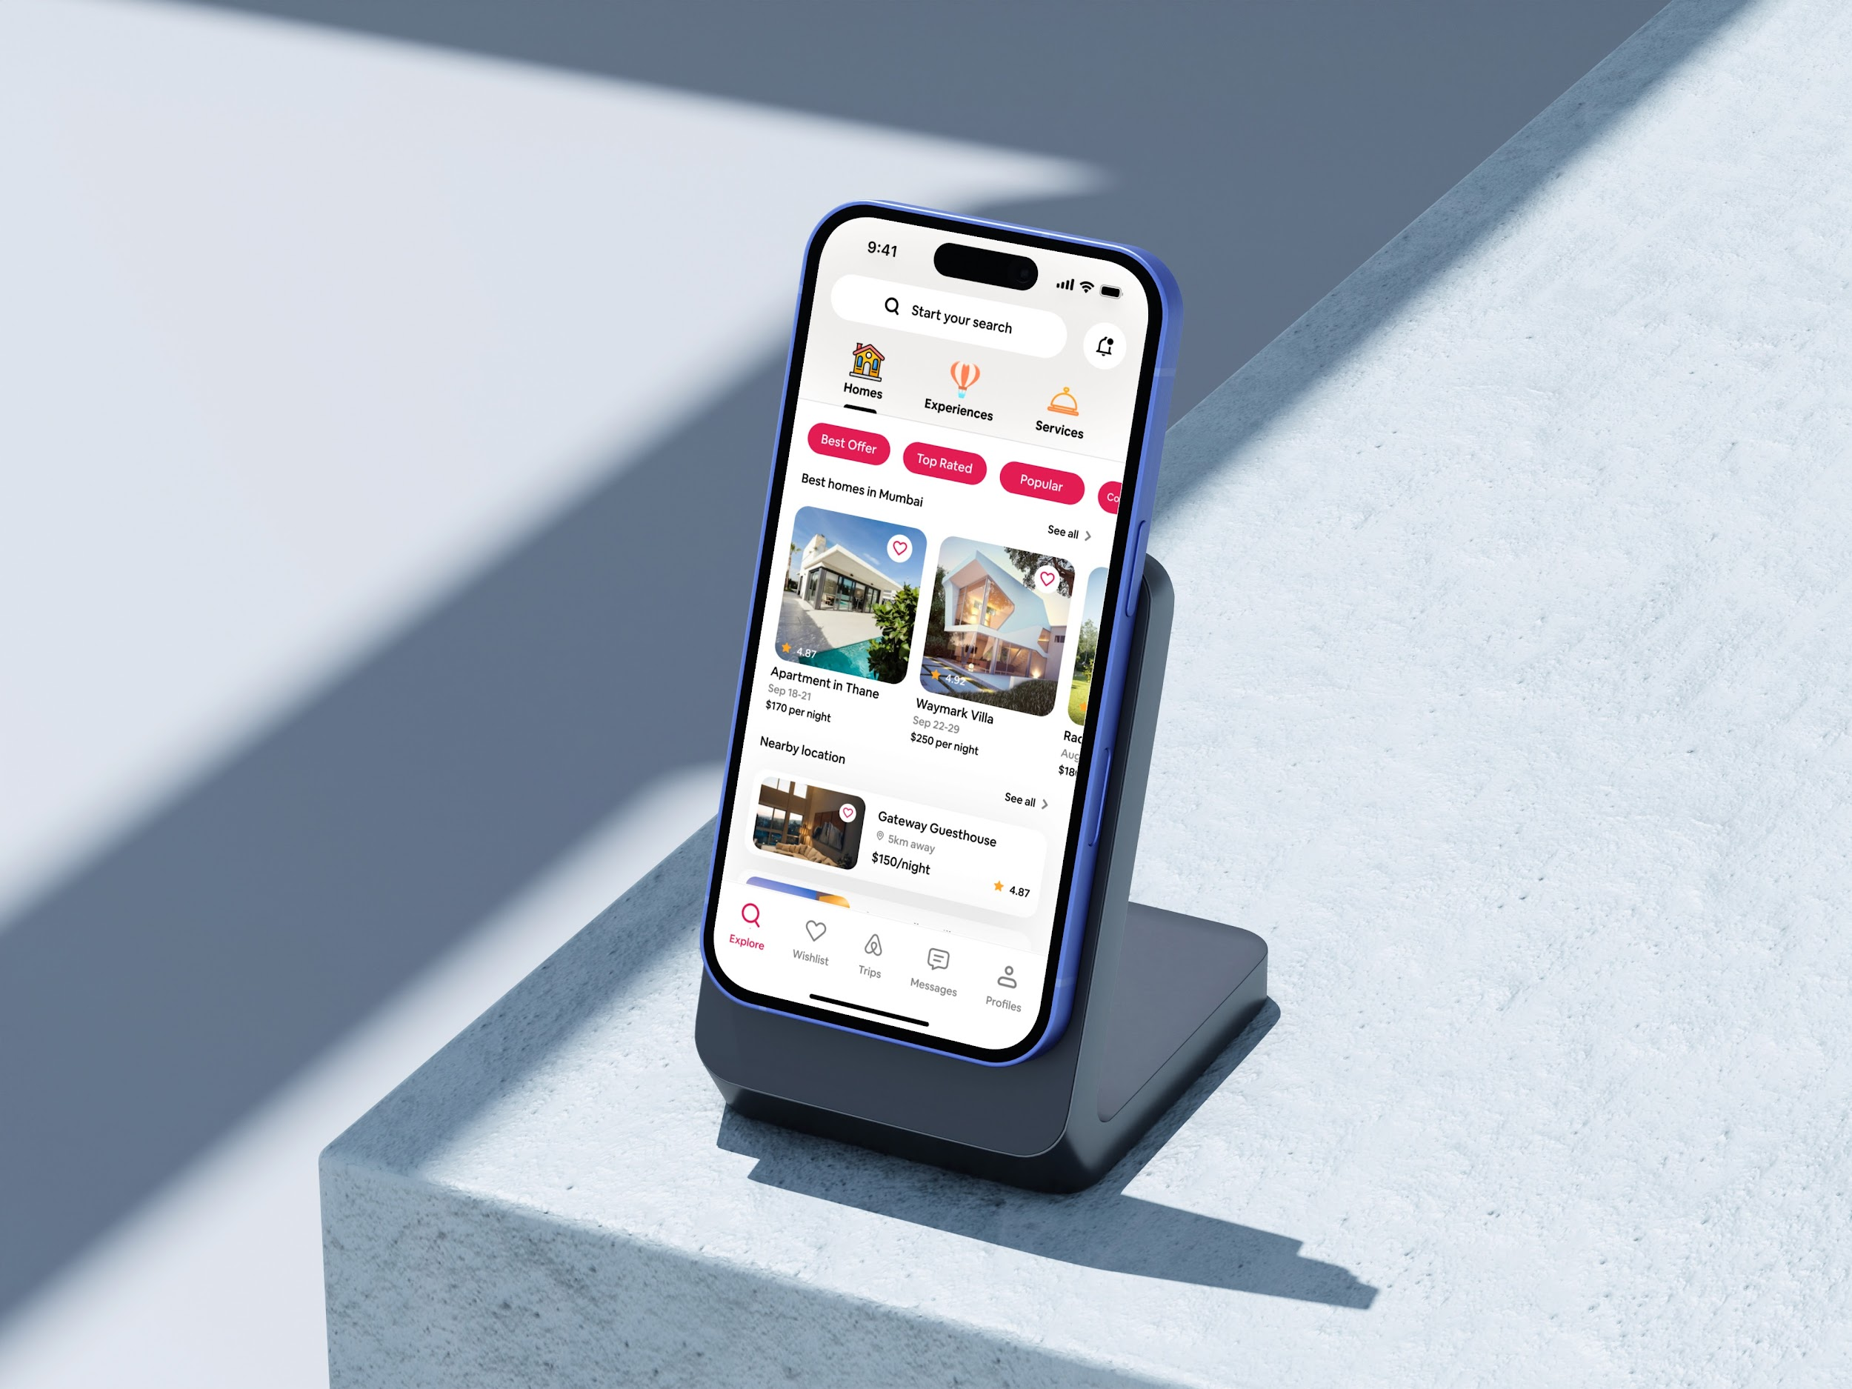
The Problem I Saw
Too many options at the start → users don’t know where to look.
- Cluttered home screen → visually overwhelming, especially if you’re in a hurry.
- No flexible payment option → if someone isn’t ready to pay everything upfront, they might leave.
- Hidden total pricing → final price only appears at checkout, which feels untrustworthy.
It was clear: Airbnb needed a calmer start and a smoother finish.
Who I spoke to (real people)
I spoke to a few of my traveler friends who actually uses Airbnb when they travel for work, holidays, or last-minute getaways.
Here’s what they said:
- “Sometimes I just want a quick booking, but it makes me scroll and tap too much.”
- “The first page is too heavy; I don’t know where to look first.”
- “I wish I could just reserve now and pay later.”
Hearing this confirmed my hunch simplicity, clarity, and flexibility were the missing ingredients.
My Design Approach
Cleaning Up the Home Screen
Instead of bombarding users with endless categories, I designed a home screen that feels lighter and calmer. The focus is on search first, because in real life, most travelers I spoke to said they already know the place or type of stay they’re looking for.
I also introduced scrollable quick filters; these aren’t just “cool labels.” They came from listening to what my friends actually prioritize when booking.
For example, one friend who travels with a pet always struggles to find pet-friendly stays fast. Another couple often checks for “romantic” or “top rated” places. So the filters were a way to bring their real needs into the design.
Streamlined Booking Flow
From choosing a stay → reviewing → booking, the flow now feels like a straight line.
- I reduced unnecessary taps.
- Made pricing transparent upfront (showing total cost including fees & taxes before checkout).
- Used visuals more than text, so users can scan faster.
This makes the booking process less tiring and better for hurried travelers.
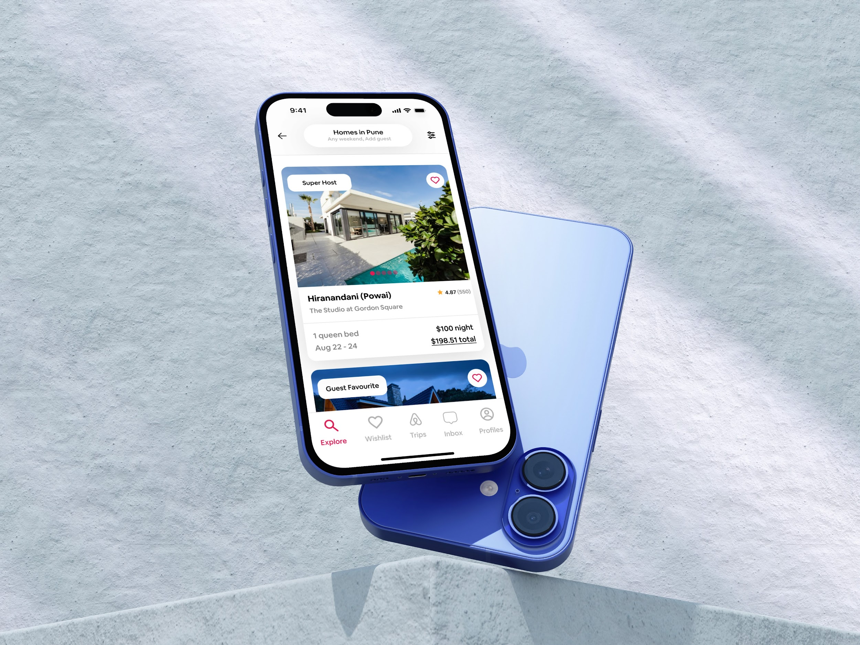
Introducing “Pay Later” at Checkout
While looking at competitors like Booking.com, I noticed they had payment flexibility that Airbnb didn’t.
So I added a Pay Later option at checkout.
- This feature helps people who may not want to pay the full amount instantly.
- It reassures hesitant users and increases trust.
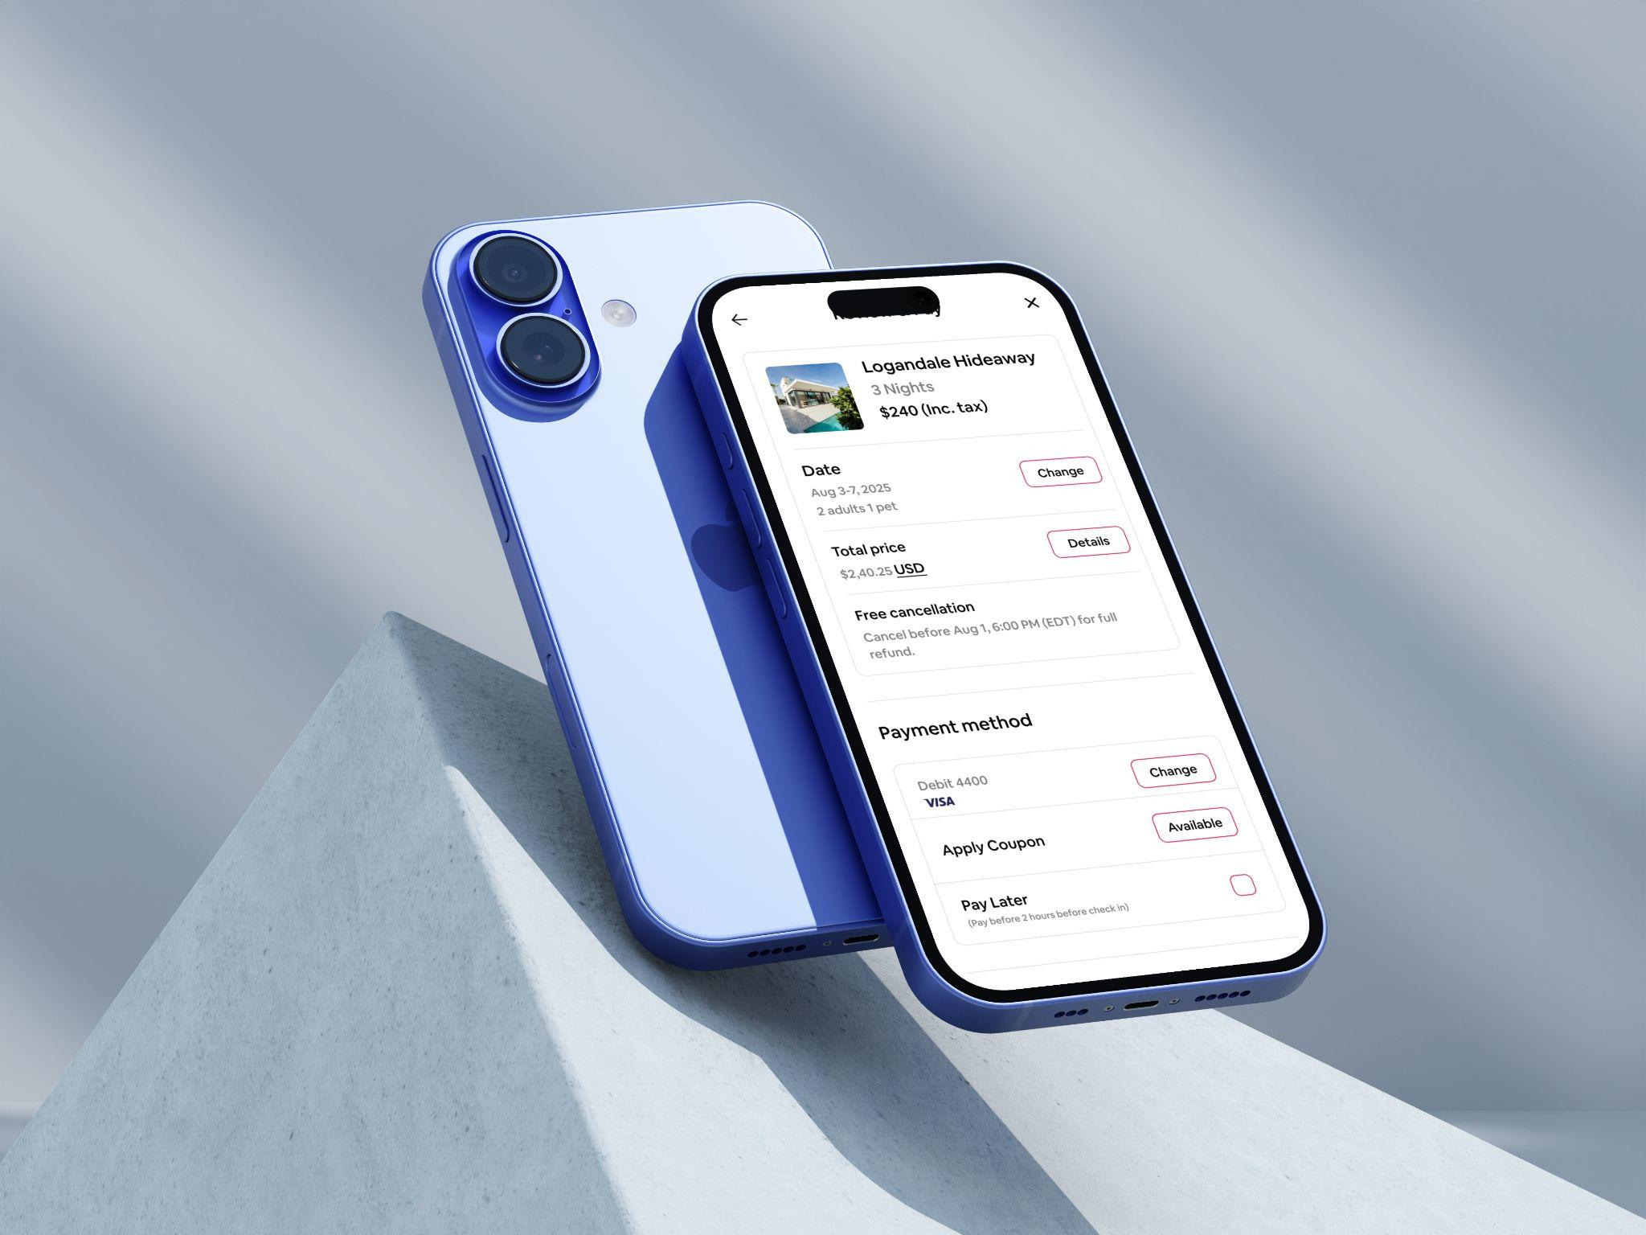

What I Learned
This redesign reminded me that design decisions should always come back to real people. By talking to my traveler friends, I realized small features (like pet-friendly filters or transparent pricing) can make a huge difference.
It also showed me that simplicity isn’t about removing everything it’s about removing what doesn’t help and highlighting what does.
With this redesign, I turned a cluttered, stressful booking process into a cleaner, faster, and more human experience.
Conclusion
Revamping the e-commerce website proved to be a game-changer in enhancing user experience and driving sales. By simplifying the navigation and checkout process, we created a more enjoyable shopping experience that significantly boosted conversion rates and customer satisfaction. This project highlights the critical role of UX design in the success of e-commerce platforms.
Figma Link: https://www.figma.com/design/hQygb4TiXafZaJXriTmu8b/Portfolio?node-id=107-3446&t=DodwlzoVxBQHuhij-1

